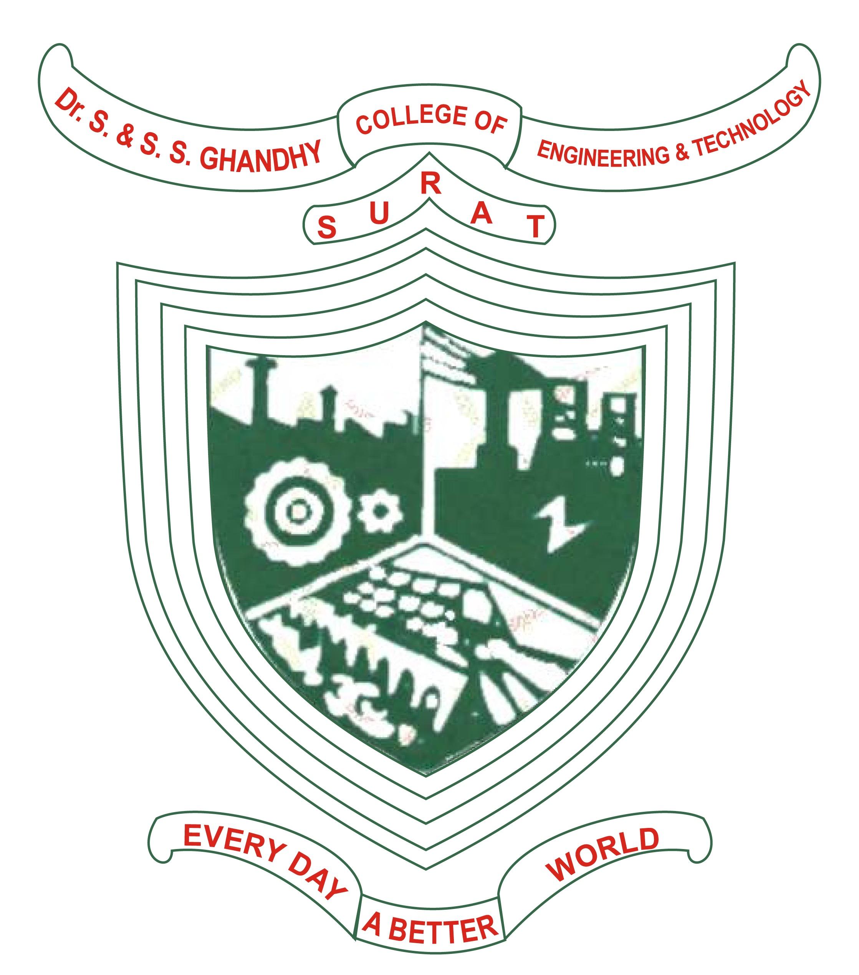
CERTIFICATE

This is to certify that project work embodied in this report entitled “Time Table Management” was carried out by Kansara Parth(206120316024), Kansara Prashant (206120316025) and Rana Prem(206120316036) at Dr. S & S. S. Ghandhy College of Engineering & Technology, Surat.
For partial successful completion of Project-I (3351605) of Semester-5 Diploma engineering in Information Technology to be awarded by Gujarat Technological University. This project work has been carried out under my supervision and is to the satisfaction of the department.
Date: Place: Surat

Under the supervision of,  Mr. Chintan Gajjar  Lecturer in Information Technology Department  Dr. S. & S. S. Ghandhy College of Engineering & Technology, Surat | Mr. J. R. Mahida  H.O.D., Information Technology Department  Dr. S. & S. S. Ghandhy College of Engineering & Technology, Surat
The Principal  Dr. S. & S. S. Ghandhy College of Engineering & Technology, Surat | External Examiner

DR. S. & S. S. GHANDHY COLLEGE OF ENGINEERING & TECHNOLOGY
INFORMATION TECHNOLOGY DEPARTMENT
Surat – 395001, Gujarat.

